[Koenigsegg Automotive –https://www.koenigsegg.com/](https://www.koenigsegg.com/)

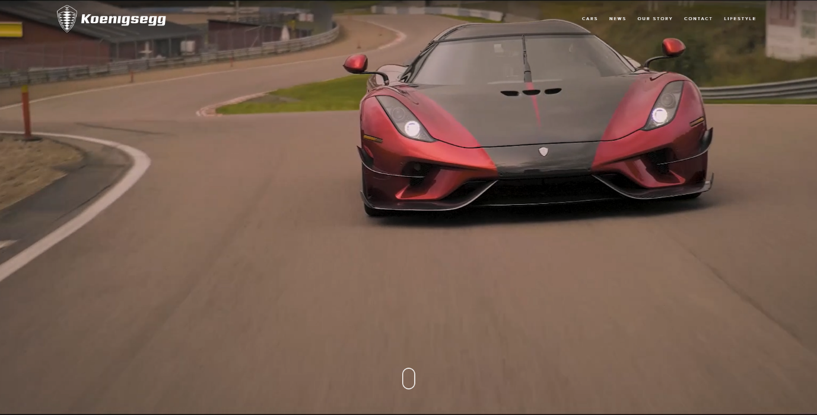

**Purpose:**

This website is an informative website on automotive vehicles that Koenigsegg sell. Their aim is to get rich people to see and buy their cars, but it is also very attractive to vehicle enthusiasts who are interested in the brand. The website is very simple to start with, but when you find the section you want to know more about, they have buried tonnes of information into the page so that there is nothing that has been missed out.

**Target Audience:**

Koenigsegg’s target audience is very sophisticated, they aim to attract people who have lots of money to spend and to spend it on their cars. They also aim to attract other car manufacturers since they like to set world records and competitive them. Car enthusiasts are also a target audience too since they will be interested in the incredibly high specifications of the vehicle and the detail in which they are explained.

**Website usability:**

The website has plenty of images and videos to show rather than to ready in order to make the website easier to use. It has clear headers. This is good since it is useful for making the navigation obvious and simple for users so that they stay to navigate the website. This is important because it means that users of all ages and disabilities will be able to navigate the web page.

**Intuitiveness (easy to learn)** 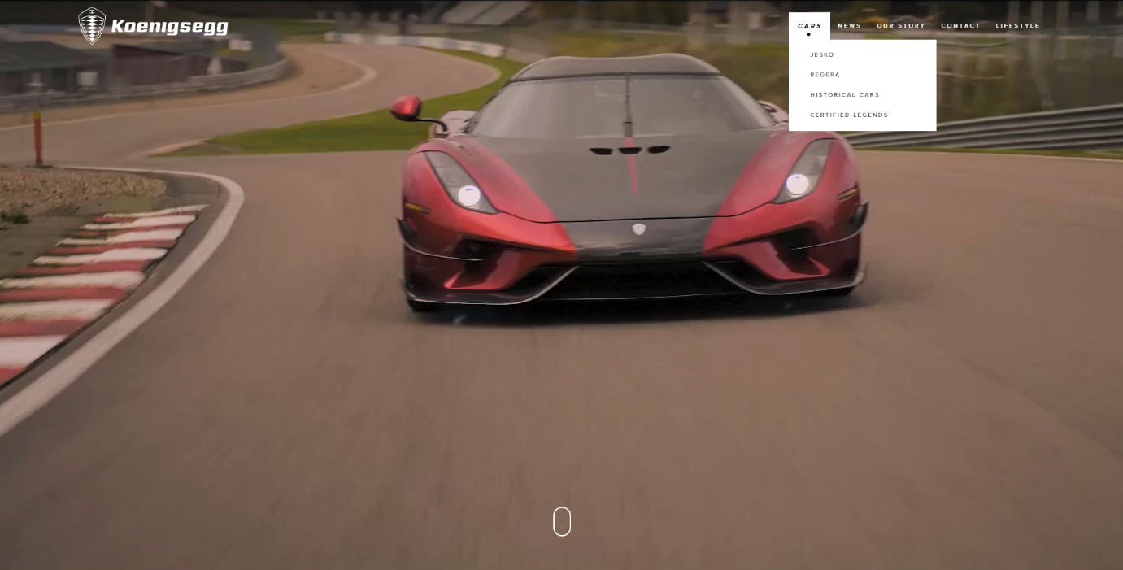

The website has a hover over function that changes the state of the text which is beneficial since it is to help the user know that they are viewing the navigation area and not some static text. However, the text original navigation button itself does not function which is why there is a dropdown menu which provides other options.

Overall, the usability is fairly simple, it is not too complicated but has more than enough information to make it useful. There are no broken links and the links are obvious at what they will lead to. This is good for the business since, their easy navigation will allow user to freely navigate and roam around the pages without issues. It is also very beneficial to the user since they are able to do as they wish within their own time and ability.

**Accessibility:**

This website does not have alt tags on it, this means that if someone who was blind, visually impaired or disabled. This is not beneficial since, someone who is disabled would not be able to navigate and/or access the website with much or any ease, meaning that they would not use the website. There is alt text on the website, this is important as people who are blind and cannot see the website for any impairment will have the ability for each of the images on the website to be read out to them by using alt text. Alternatively the alt text is also to be used if an image file corrupts or gets lost, the alt text still states what the image is of.

**Multimedia:**

On the website, there are photos and videos, they will need to make sure that users can enjoy the multimedia that Koenigsegg wants to share with their target audience. The videos have the best impact on the user depending on how they can access and watch the video would be: they have youtube video links so that the website does not take longer to load as the file is not on the website, the link is. The videos are high quality, having a high quality video means that as many users can view it as possible, people who are visually imparied will not be able to view the video, so having the ability for there to be narrative speech over the video as an option means that visually impared members and other audience will be able to hear the video. For people who are deaf, the video needs to have subtitles, doing this allows deaf persons to have access to watching the video as they can read words being said and other noises that are exclaimed.

**Typography:**

There is a lot of text on this website that is quite sophisticated since it accurately explains and provides all of the information about the things that Koenigsegg do. This is not a great thing to people who do not know much about cars, however, to people that do, it is very precise and informative. For people who do not know as much, they may choose to back off from the website, meaning that the business will have lost potential business and exposure to the world.

**Layout, alignment and whitespace:**

This website has a very neat and professional layout, doing this will allow for users to be able to navigate the website much easier and therefore Koenigsegg will not receive as harsh criticism for their website since their navigation through layout is well thought through and done. This is important because Koenigsegg is a professional company and they do not want to be seen as otherwise because of a sloppy and impulsive website.

The alignment on the website is well done, it is consistent and very particular. The navigation menu is located at the top right throughout all of the pages which is effective since it means the users will always know where it is and it is unlikely they'll get confused. They have placed images and videos as the first section which is very clever to see when the website is looked at, however, some of the videos and images are intrusive to the navigation bar since the background of the video and the text colour is matching.

The website is a frontal appearance to the organisation, which is important for the business and the alignment needs to be of good quality, if it is not, the users will not be able to access the website with ease and this will not make Koenigsegg look very professional and well organised, it would make users think that they do not care about their appearance.

**Key words:**

Koenigsegg - Shows up 3rd search:

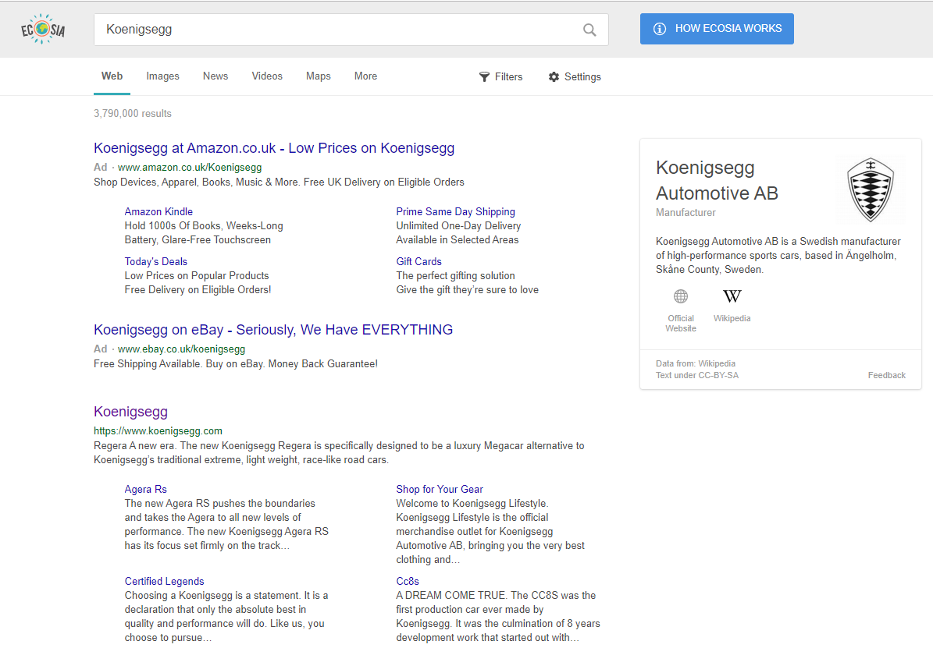

Cars Koenigsegg - Shows up 4th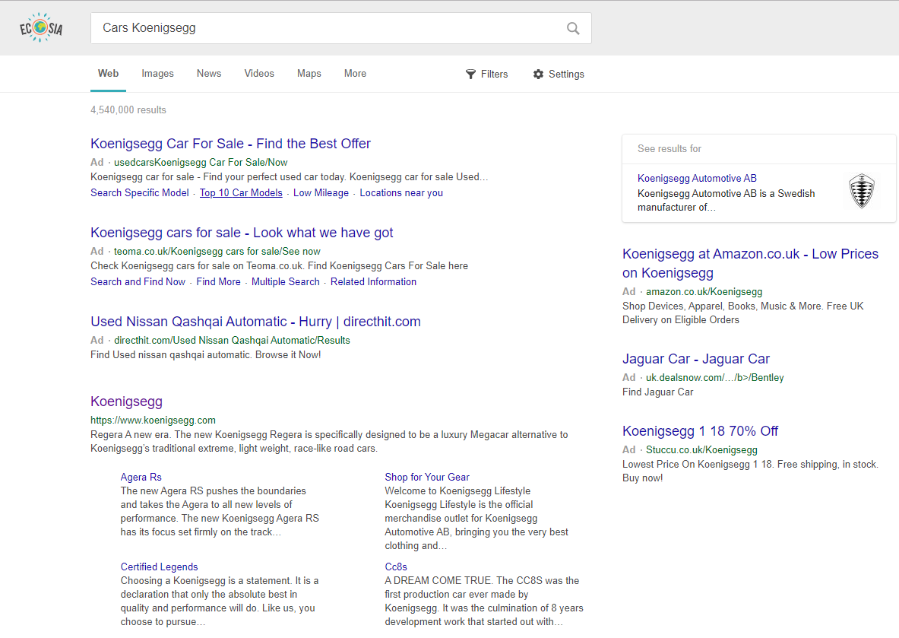

World Record Koenigsegg - Shows up 3rd

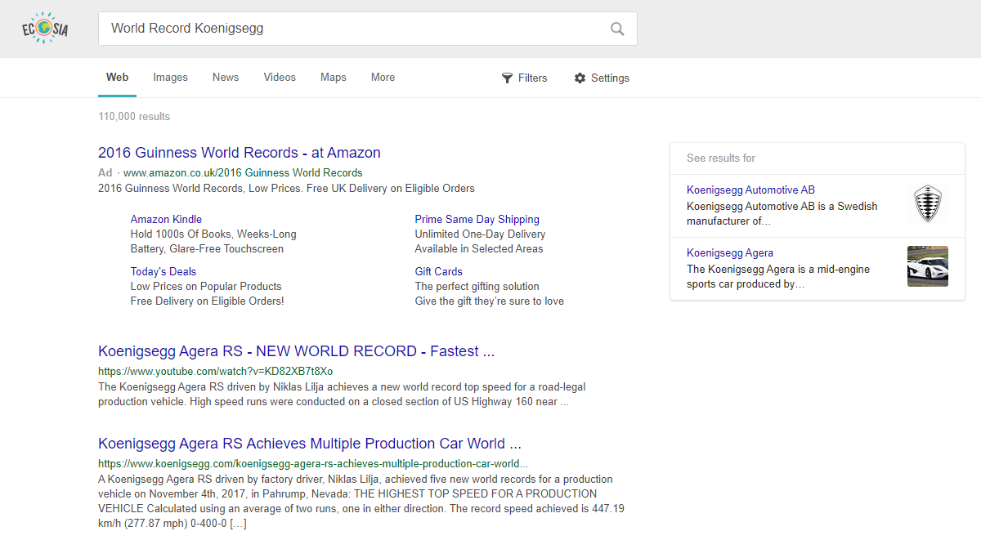

**Ranking:** The reason it is beneficial for the website to rank highly on Google results is because it saves the user time having to directly search for them (especially if they don’t know anything about them). It allows Koenigsegg to be more likely to be pressed on since it is one of the first few results and the most convenient to the brand.

**Impact on business objectives:**

The only business object ranking highest would achieve is the ability for the company to spread their brand to a much wider location globally.

**Impact on User needs:**

Ranking higher on the topic searches provided is useful to users since it provides a direct link to their organisation and what they are all about. It is not particularly useful to people who want to buy their cars since they do not provide the service in which to do so, this is done through third party organisations such as ‘SuperVettura’. Although, this ranking is useful to people who want to be informed about the specifications of the vehicles, their blog or about them and a company and their journey.

**Optimization:**

**iPad:** 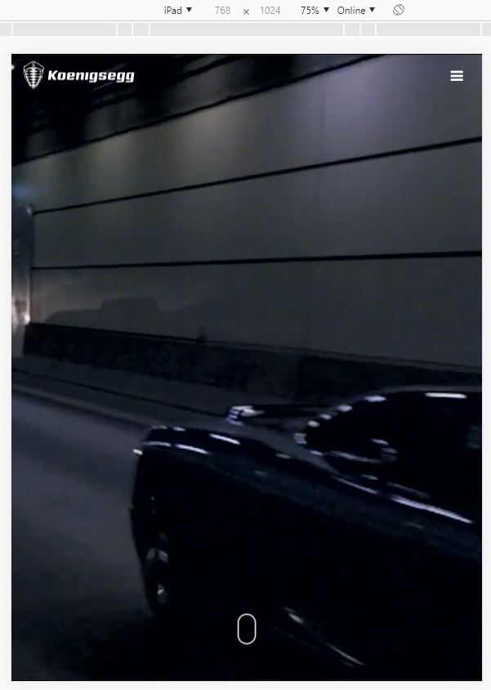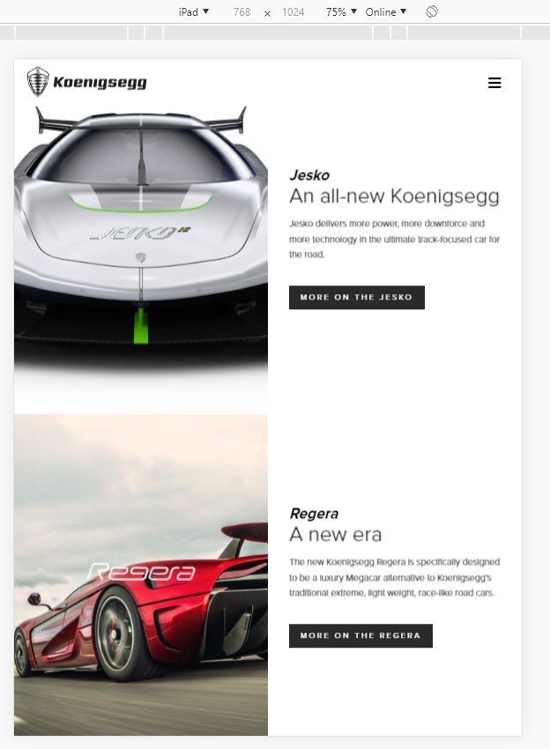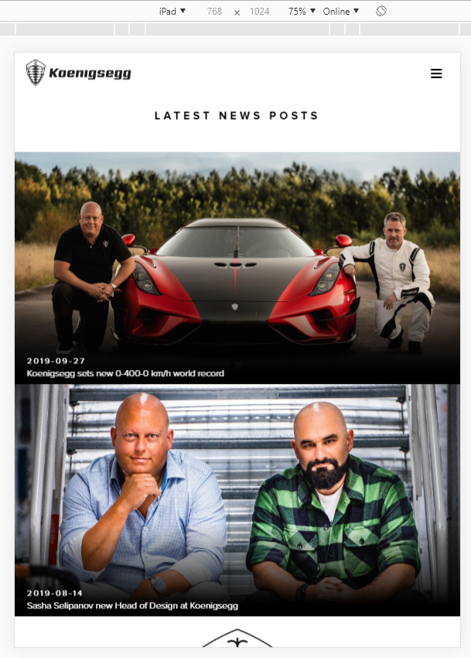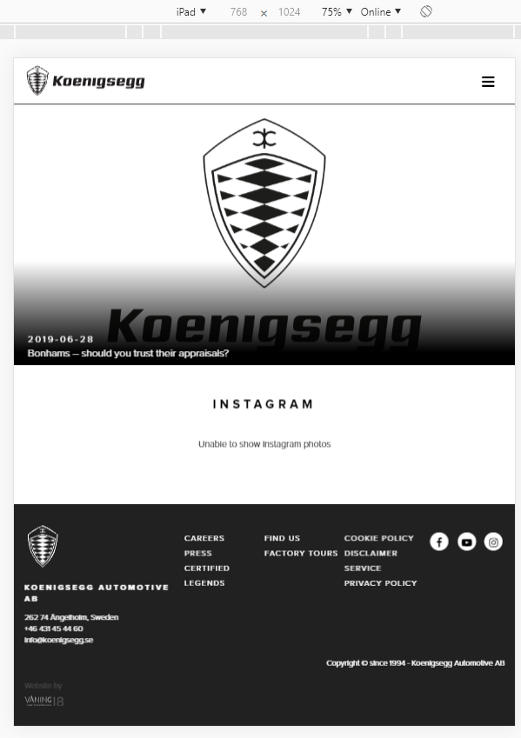

**iPhone:** 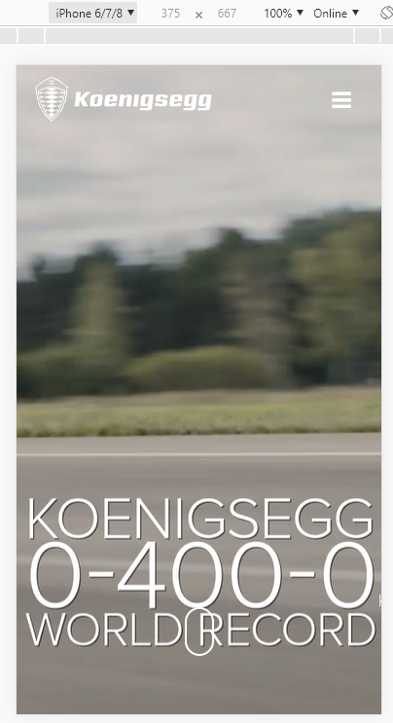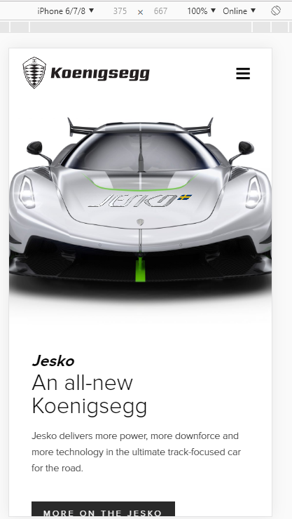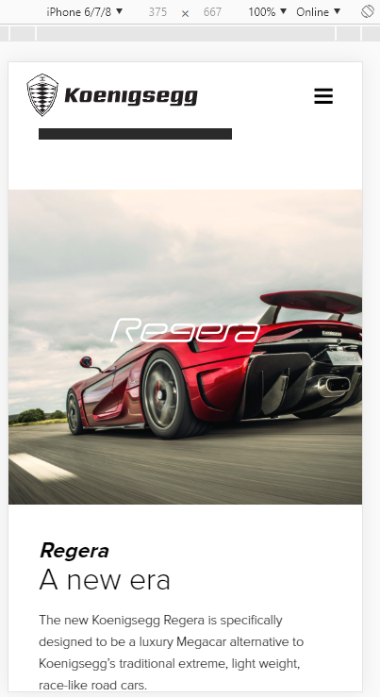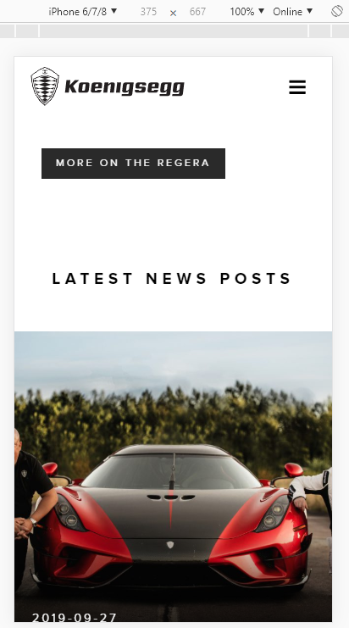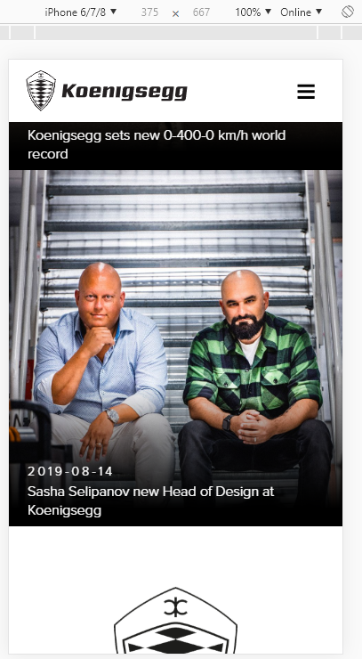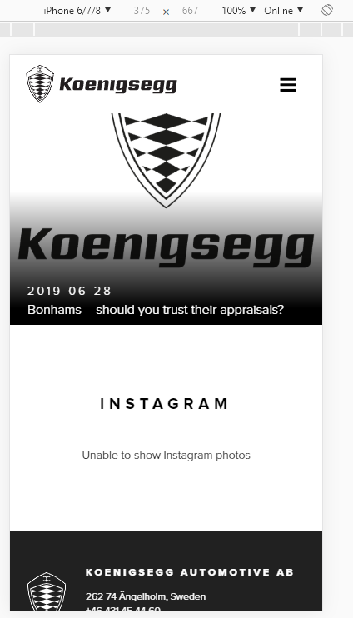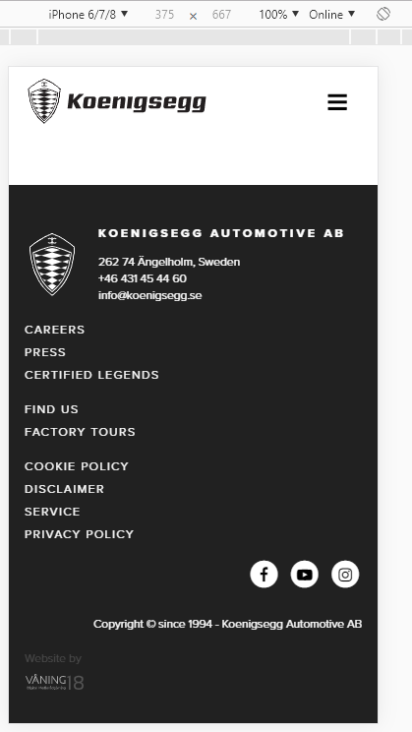

**Why is it important for pages to load quickly?**

Whilst all of the other searches will link them straight back to Koenigsegg, they don’t want people to go back to the search results because of the waiting time for pages to load. This can be done by compressing images and videos to save storage and then prevent having to have users download large video and image files, however, Koenigsegg may not be as knowledge rich in website development as much as they are in motor vehicle development.

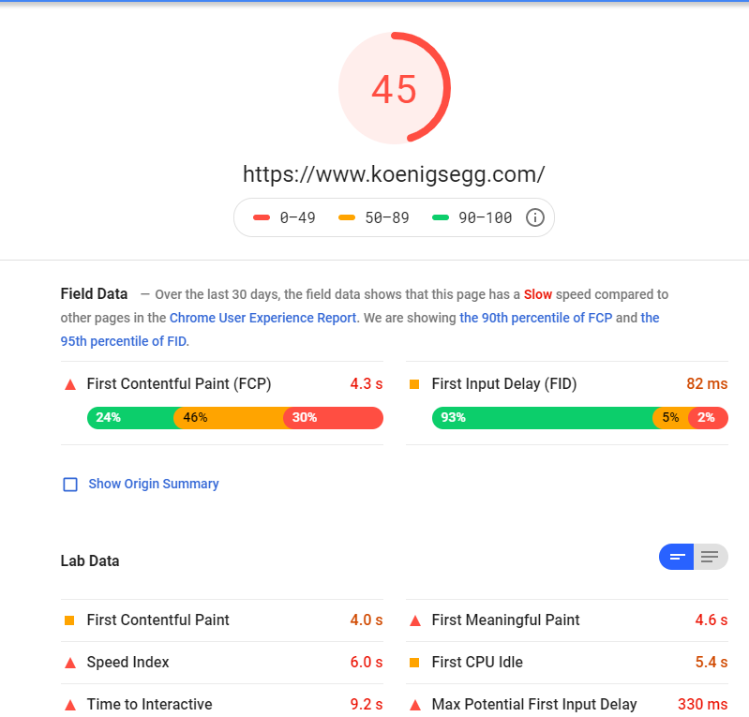

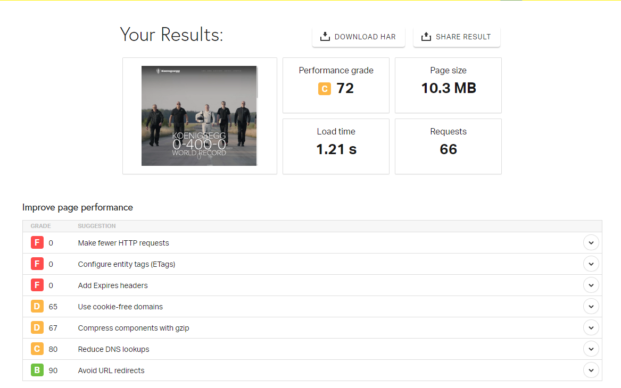

Website Screenshots:

Chrome:

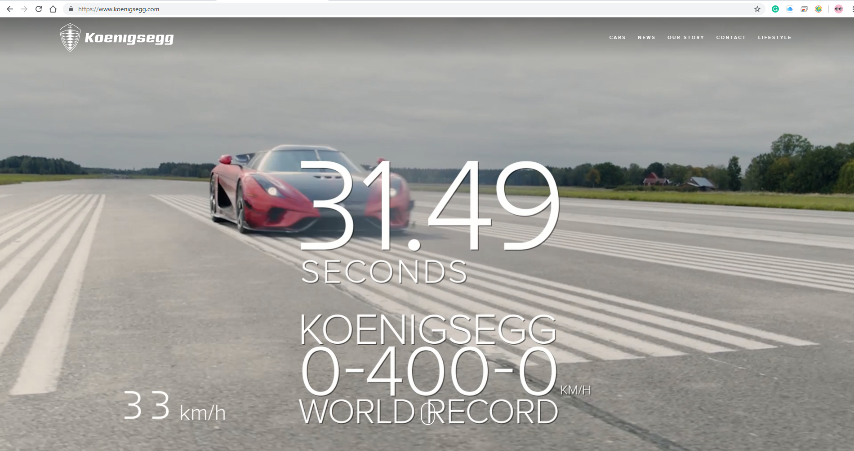

Edge:

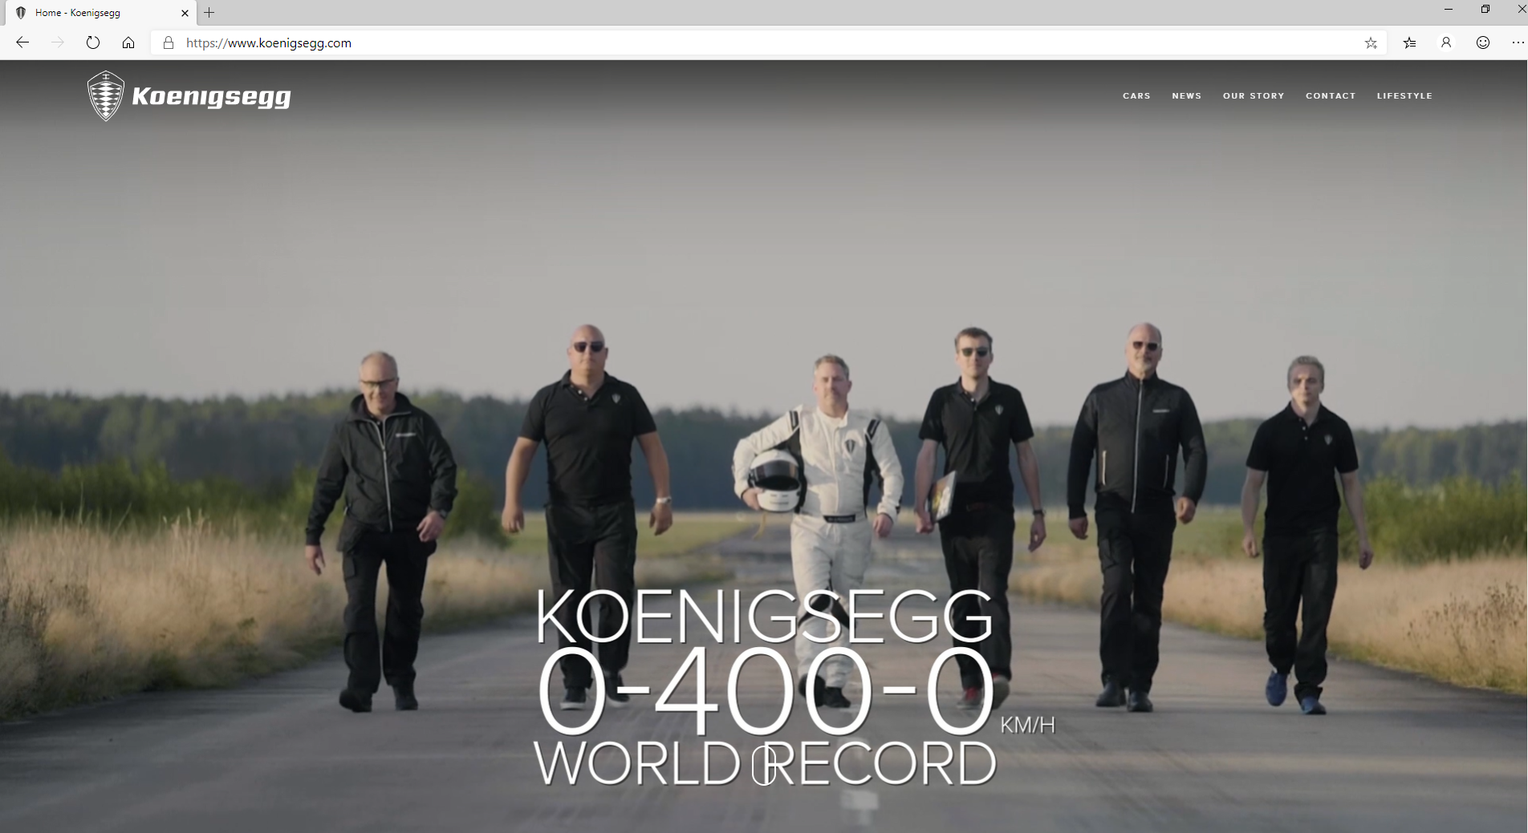

Internet Explorer:

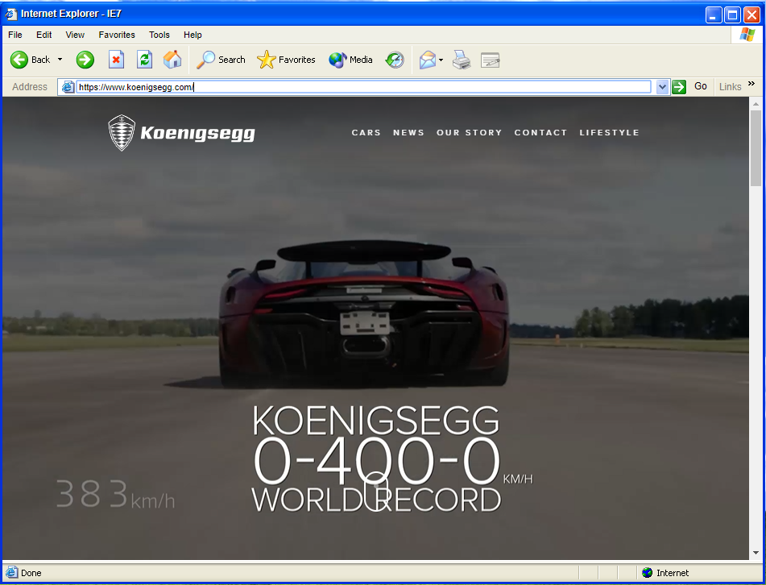

Findings:

I found that all three of the browsers handled very similarly. They all load the correct navigation, they all play the background images and videos perfectly. The webpage fits very well into the browser from their different sizes.

[Malvern Civic Society](https://www.malverncivicsociety.org.uk/) - <https://www.malverncivicsociety.org.uk/>

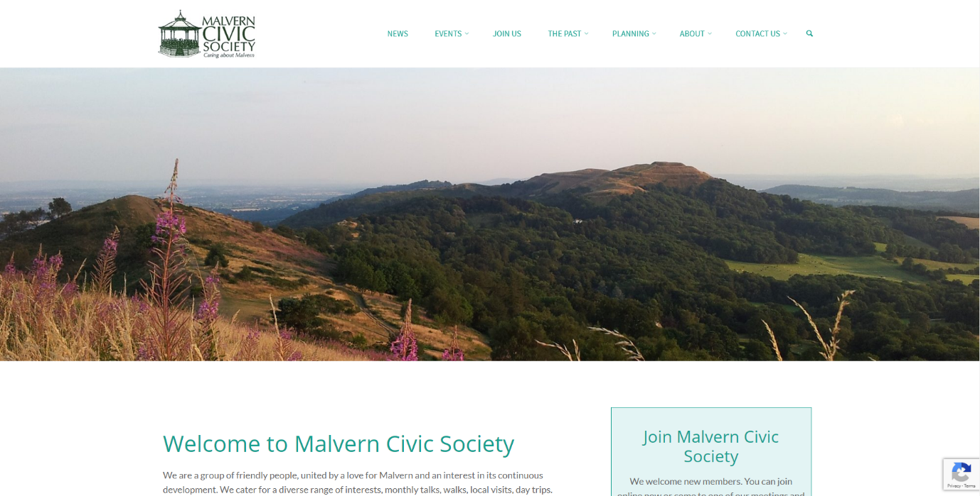**Purpose**:

This website is an informative website upon the Malvern Civic Society and what they do. It has lots of information dedicated to news, events, their past, planning, contacts and their about page.

**Target Audience:**

Malvern Civic Society’s target audience is mainly pensioners who have lots of free time and want to join a society. The target audience will also be people who have general interest in some of the things that the society do too.

**Website usability:**

The website has lots of usability. For example, it has navigation links which are simple. It uses simple wording to help with making certain navigation more obvious and simple. This is important since it will allow for users of all ages and disabilities to be able to navigate and access this website. MCS has done this well since all of their headings have names and even the ability to find more specific information since it has a dropdown menu.

**Intuitiveness (easy to learn)**

The website needs to be intuitive and easy to learn, this is because the target audience are majorly not very skilled in websites and how they work, so using initiative in order to make the website simple and easy means that they are likely to spend more time on the website actually taking in the important information that we want them to read as opposed to spending time on the website getting disgruntled.

Impacts

For the organisation, the ability to use this website with ease is very good as it will allow for MCS to attract and retain more users as its website is very simple but pretty. The website has pictures, it is not sloppy or impulsive and it is very neat. This is important because MCS needs to attract people in order to grow within their area and more importantly they need to retain their members, if they do not do this, they may not get very good reviews slimming their chances of attracting new members.

For the users, it is vital that their requirements are met when the website was designed and made, otherwise they would not or negatively impact from the decisions made, because of this they may not choose to be members

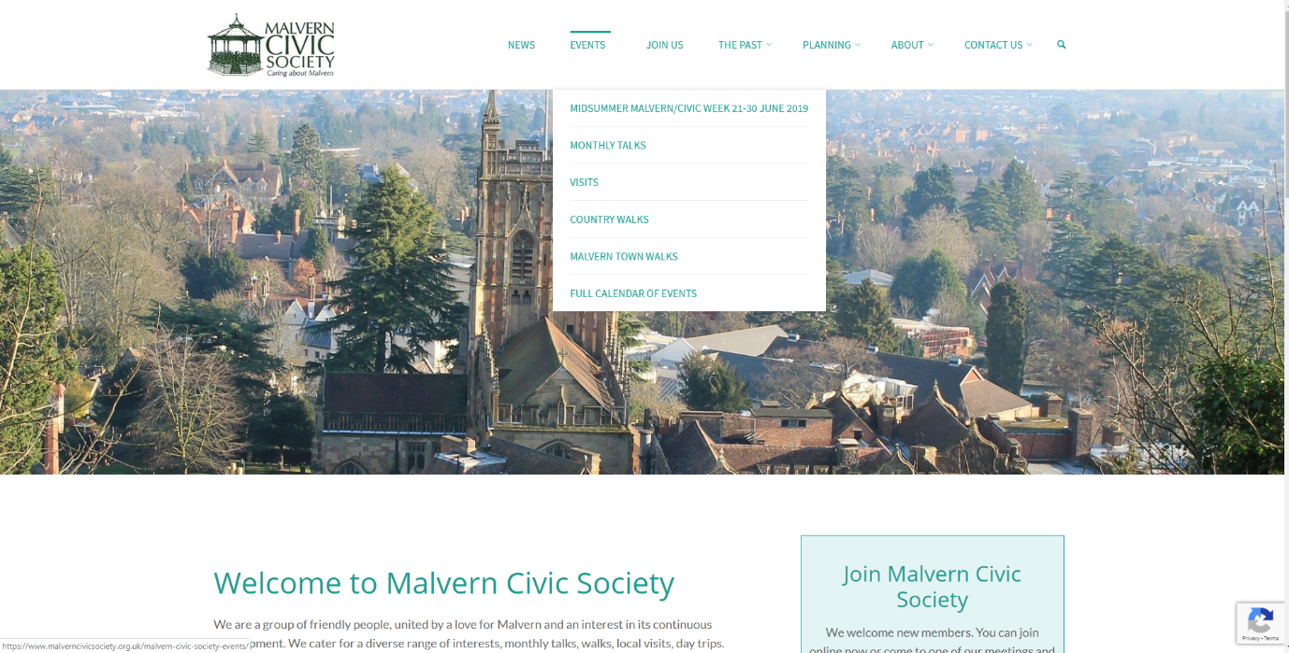

The site has a hover over feature that changes the nation of the text that's created to help the consumer know that they are viewing the navigation vicinity and no longer some static text. The navigation button itself does feature a dropdown menu which presents different alternatives to view .

Overall, the usability within reason simple, it is not too complicated but has greater than sufficient statistics to make it useful. Equally there are no damaged hyperlinks and they are fairly apparent at what they may lead to. This is right for the enterprise seeing that, their smooth navigation will permit consumer to freely navigate and roam around the pages without problems. It is also very good for the person wishes due to the fact they are able to take as much time as they need to navigate and they do not feel forced to

**Accessibility:**

Lacks access keys

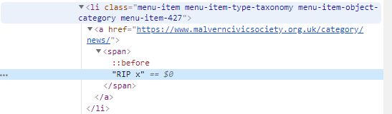

The website is lacking access keys, this means that if there is a user who needs to use a specialised keyboard to navigate the website, they cannot since there isn’t a way for them to specifically choose certain navigation menus as the website lacks the specific access keys to be able to use this function.

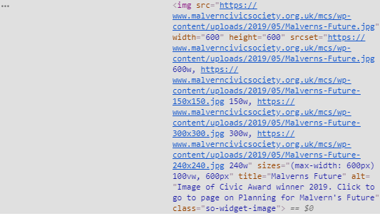There is alt text on the website, this is important as people who are blind and cannot see the website for any impairment will have the ability for each of the images on the website to be read out to them by using alt text. Alternatively the alt text is also to be used if an image file corrupts or gets lost, the alt text still states what the image is of. On the website, there are photos.

**Multimedia:**

I think that if MCS were to have videos, they will need to make sure that users can enjoy the multimedia that MCS wants to share with members and their target audience. The way this would best impact the user on how they can access and watch the video would be: it was a youtube video link so that the website did not take longer to load as the file is not on the website, the link is. The video was high quality, having a high quality video means that as many users can view it as possible, people who are visually imparied will not be able to view the video, so having the ability for there to be narrative speech over the video as an option means that visually impared members and other audience will be able to hear the video. For people who are deaf, the video needs to have subtitles, doing this allows deaf persons to have access to watching the video as they can read words being said and other noises that are exclaimed.

**Typography:**

The contrast of the website is fairly poor. This is because the text that they have chosen is a very bright pastel colour which is not very visually good for the website, whereas a dark colour such as black, or even dark green instead of light green would be better for the website.

**Keywords:**

Malvern Civic Society - Shows up 1st:

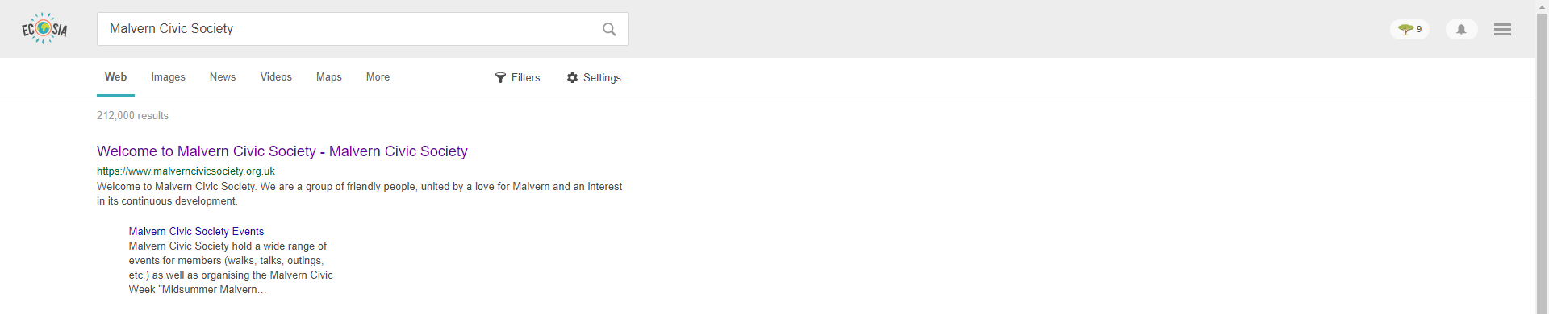

Events in Malvern - Doesn’t show

Restoration Malvern - Doesn’t Show

Social Clubs Malvern - Doesn’t Show

Societies Malvern - Shows up 3rd:

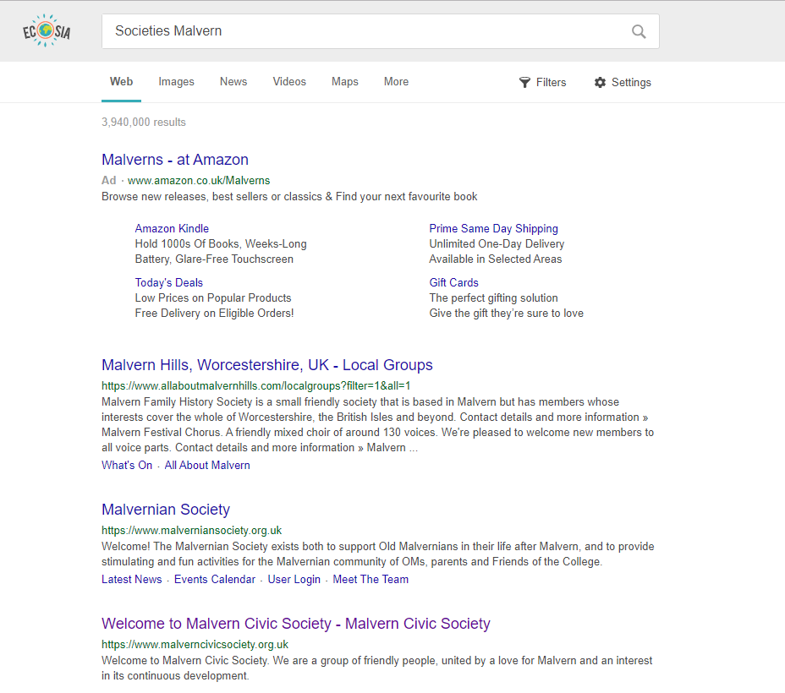

History Malvern - Doesn’t Show

Conservation Malvern - Doesn’t Show

Commemorative Malvern - Doesn’t Show

**Ranking:**

The reason it is beneficial for the website to rank highly on Google results us because it saves the user time having to directly search for them (especially if they don’t know anything about them). It allows MCS to be more likely to be pressed on since it is one of the first results and the most convenient.

**Impact on business objectives:**

The impact on the business objectives are relative to the ranking on the website. If the website ranks high, therefore gaining lots of views the business will be able to apply for advertising, but they will also be promoting what MCS do.

**Impact on User needs:**

For users, it is beneficial if the ranking is high since it is the most relevant to the search topics, and therefore makes accessing the information much easier for the users.

**Meta Keywords:**

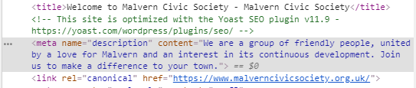

This website does not have any meta keywords.

**Optimisation View -**

**iPad:** 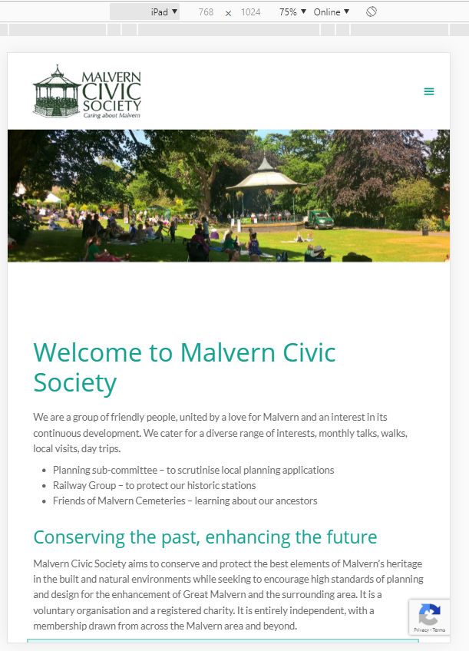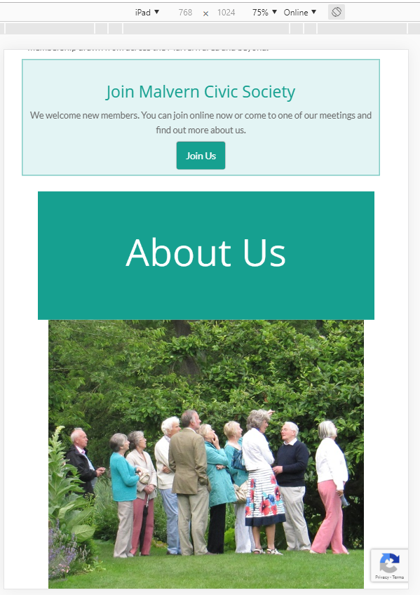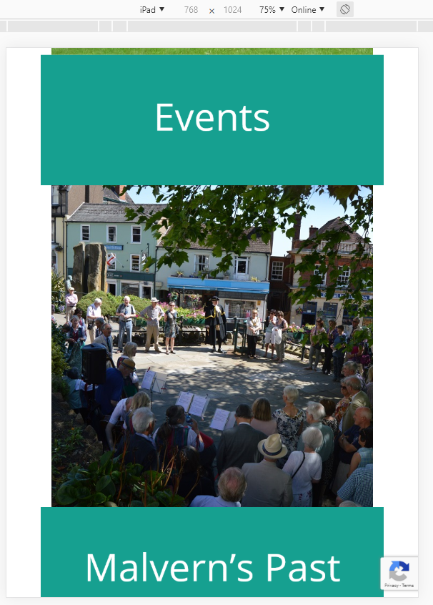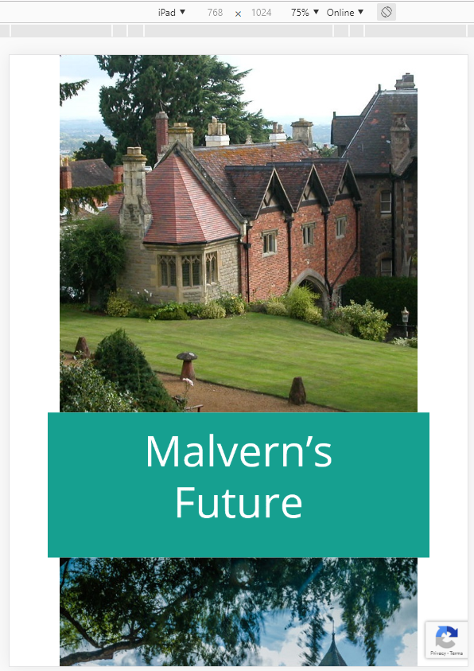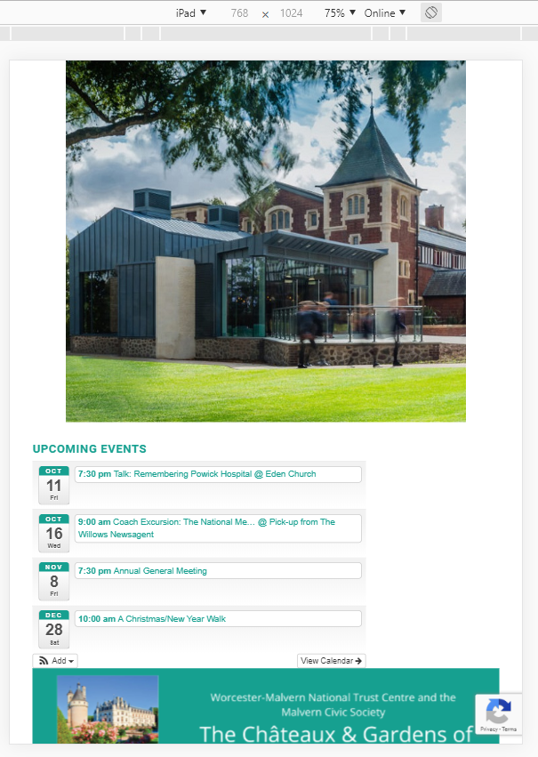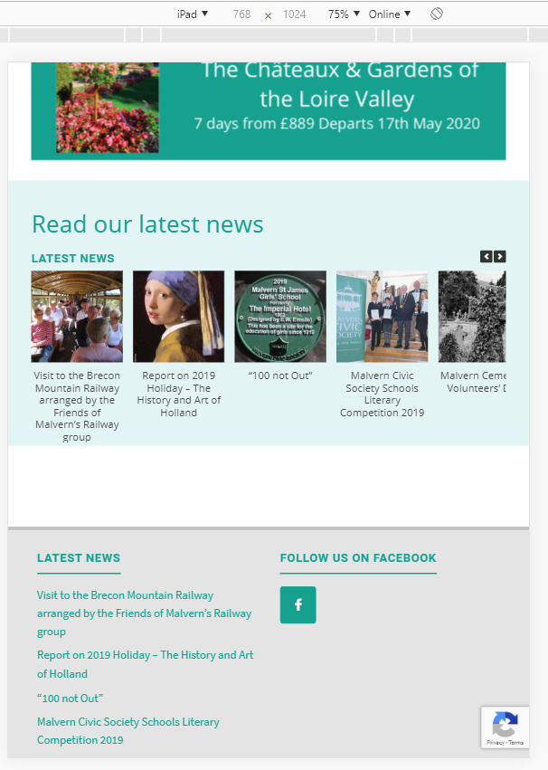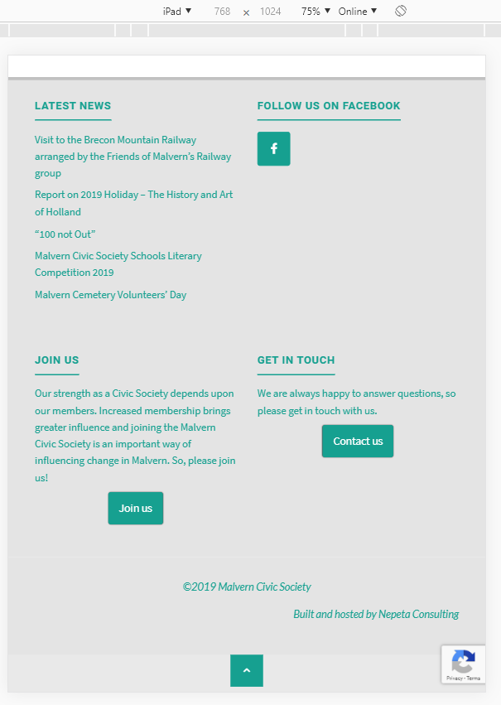

**iPhone:**

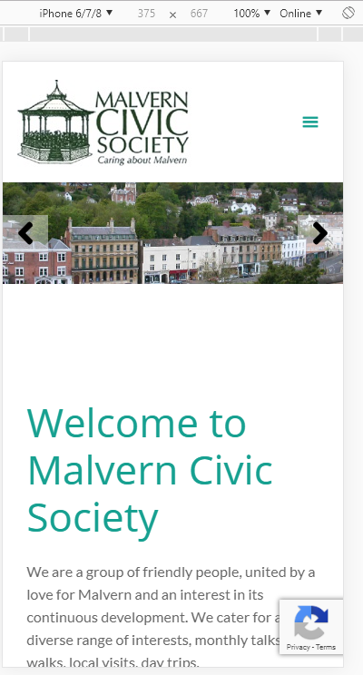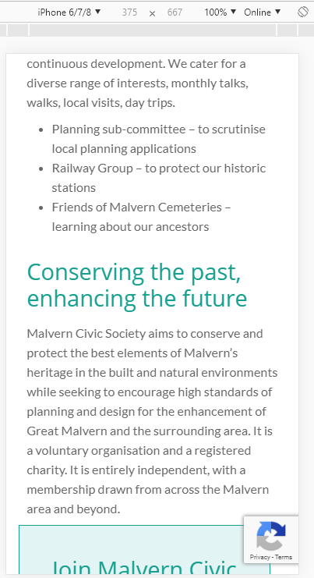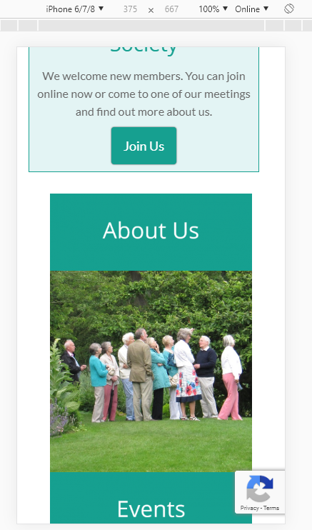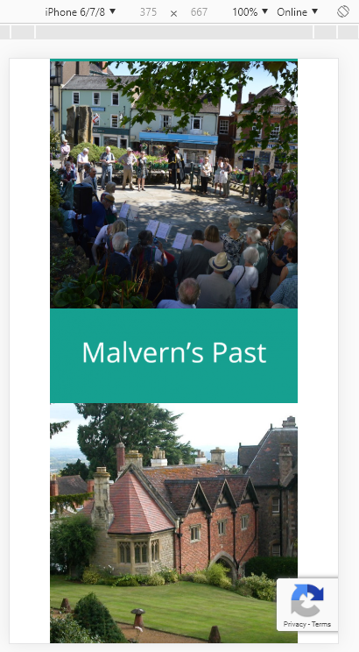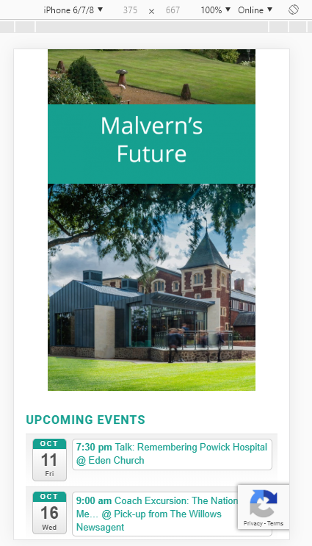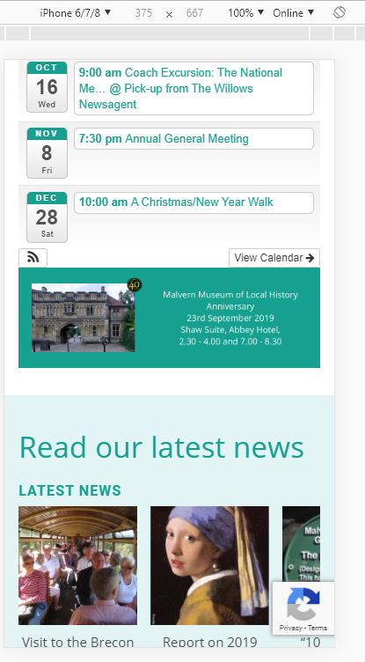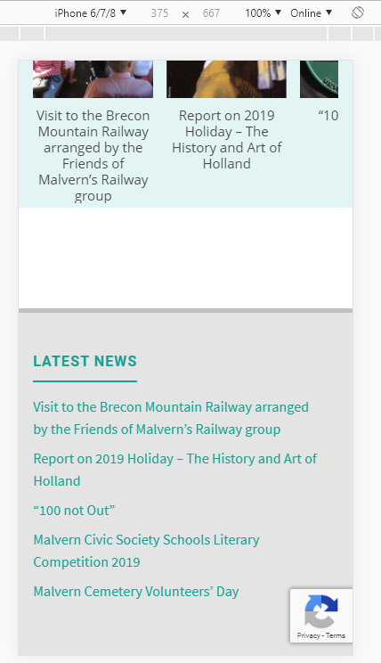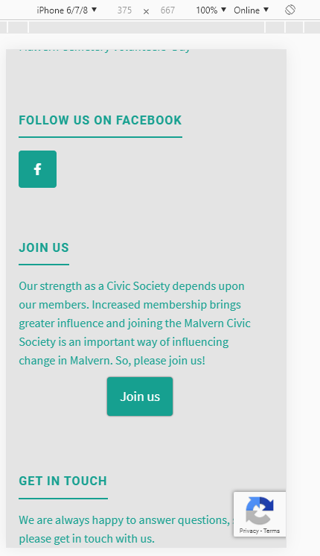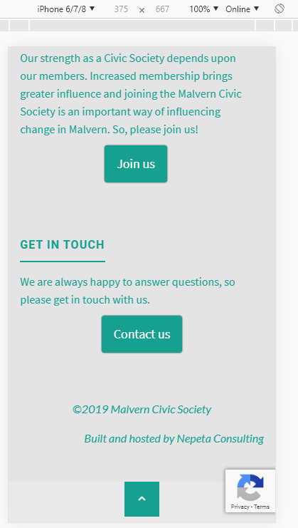

**What’s the difference between Adaptive and Responsive design:\***

Responsive design is when the webpage reacts to how the screen is shaped. Adaptive design is when the page is shaped to breakpoints and does not react after it has loaded.

Responsive design is beneficial for users who use mobile devices, tablets and special monitors since it fluidly reacts to how the screen is shaped, however, adaptive design is not particularly great for changing screen size, or orientation.

**Why is it important for pages to load quickly?**

This is mainly because of a business objective, but if a page takes too long to load, the user may go back and try a different website, meaning they have lost potential clicks.

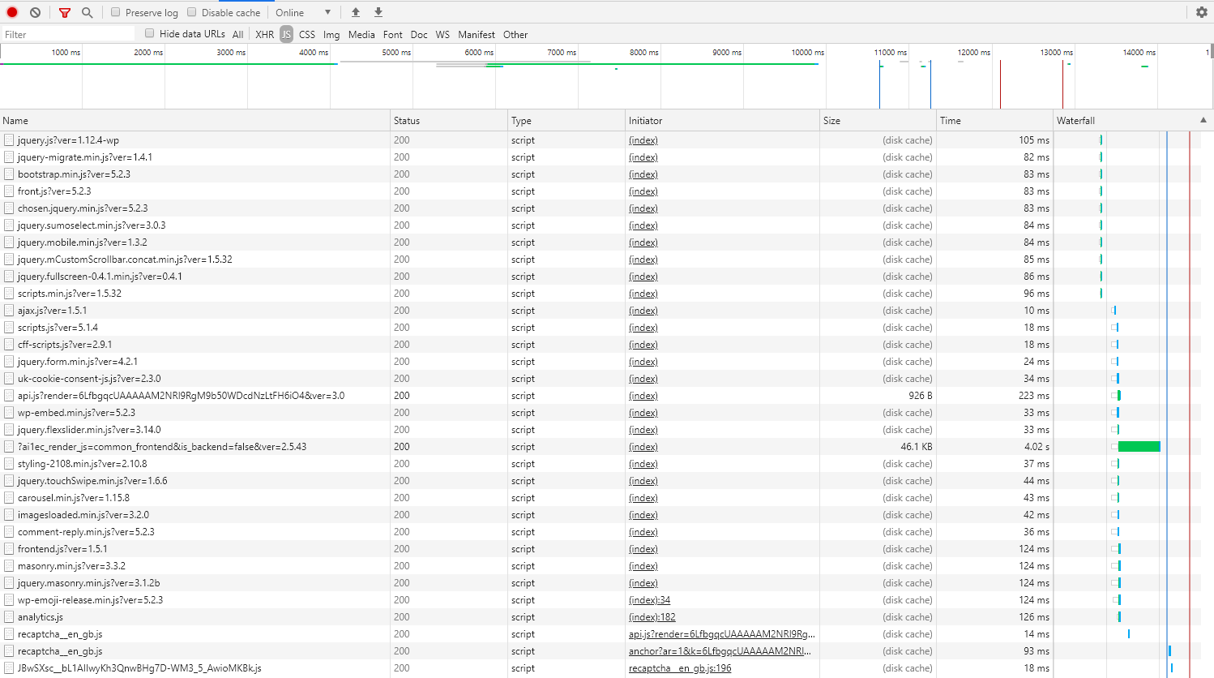

**What is the impact?**

It may cause a user to stay and read (loads quickly) or go back and read elsewhere (long waits).

**Why is the load time affected by this file?**

Because it holds all of the most important data in order for the website to load, without this there would be a lot of missing content.



This file is what causes the website to take much longer in loading. It is an important file however.

<https://tools.pingdom.com/#5b62ee4368800000>

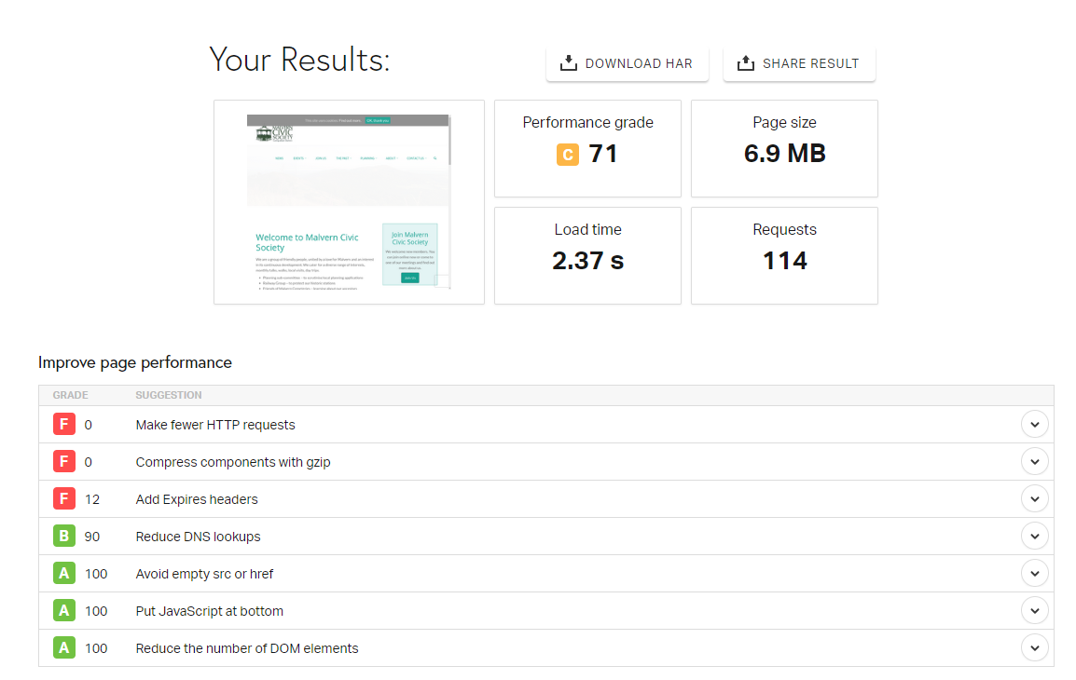

Resolutions

Operating Systems

Device

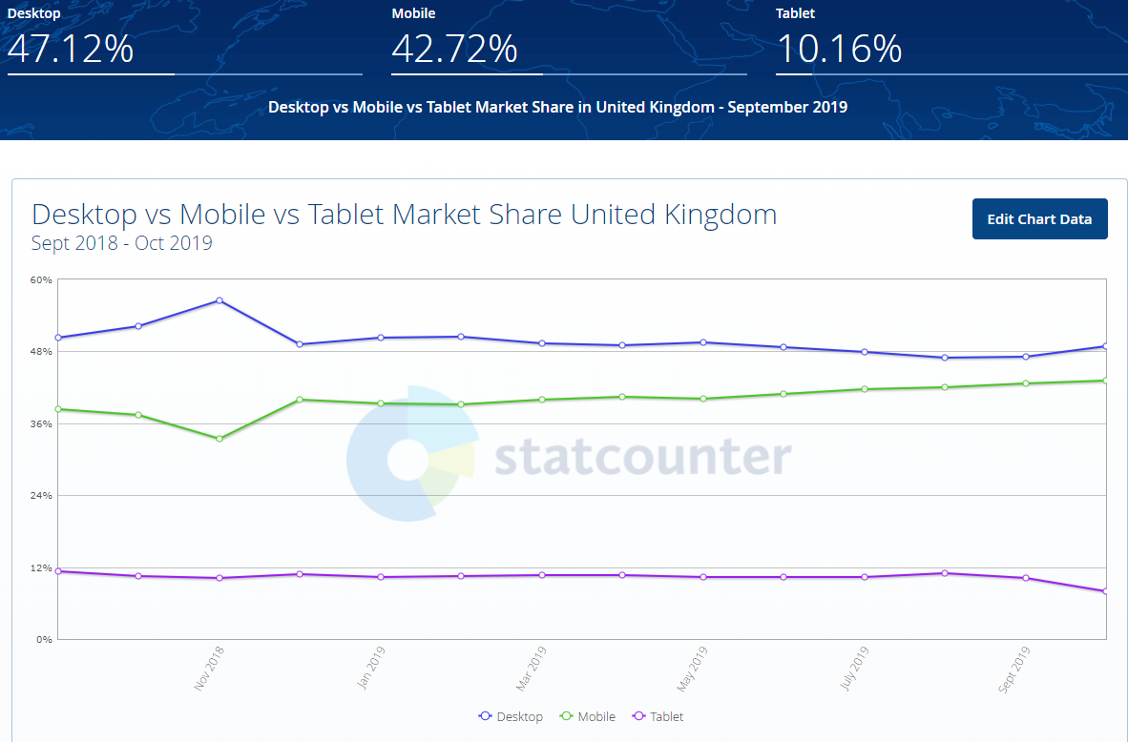

Browser

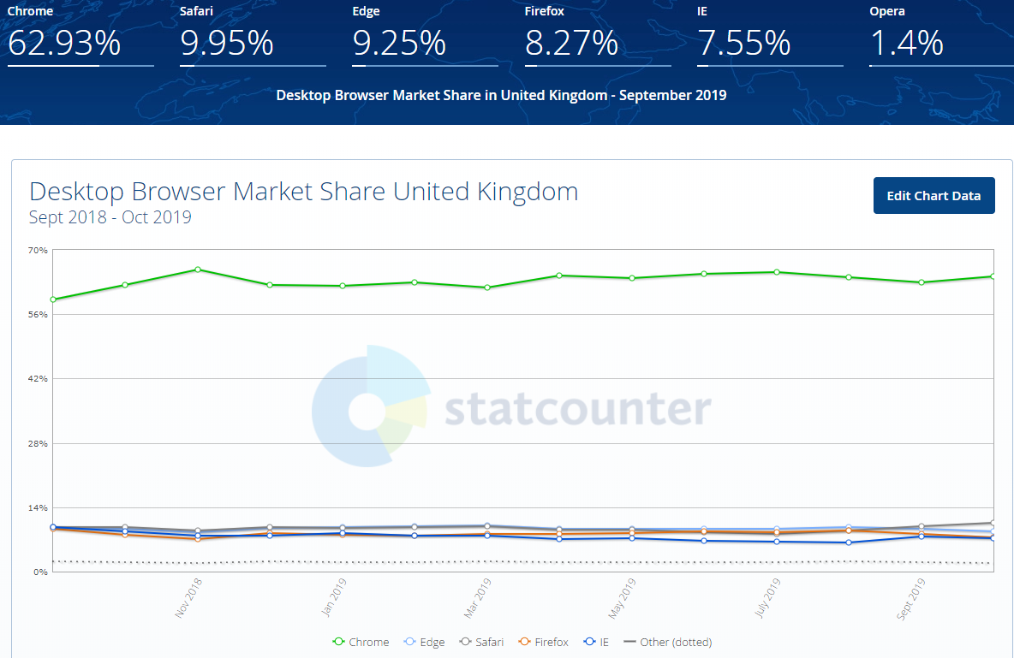

Microsoft Edge:

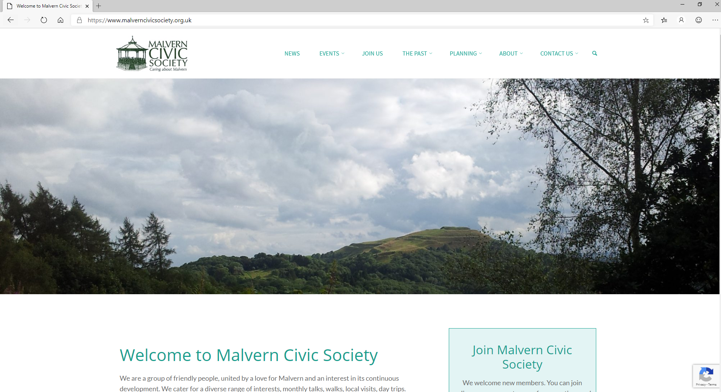

Chrome:

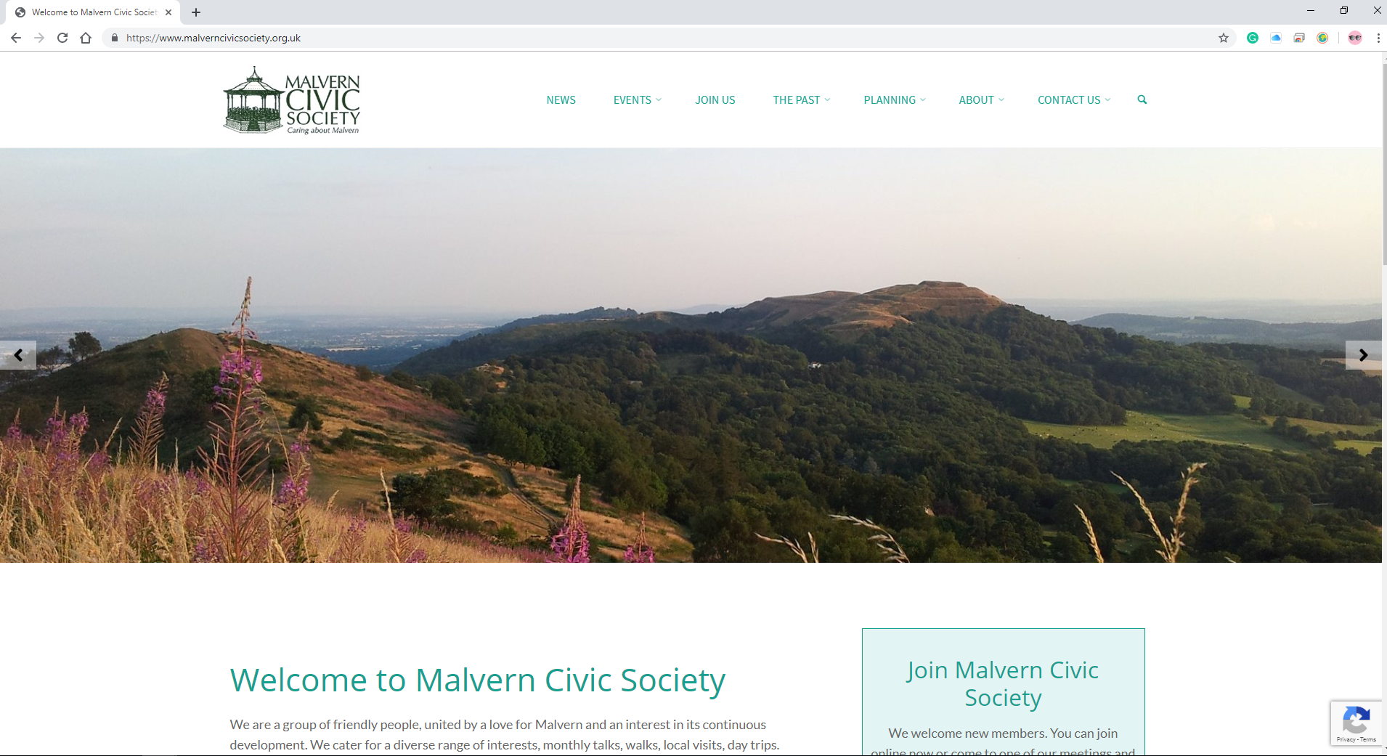

Internet Explorer:

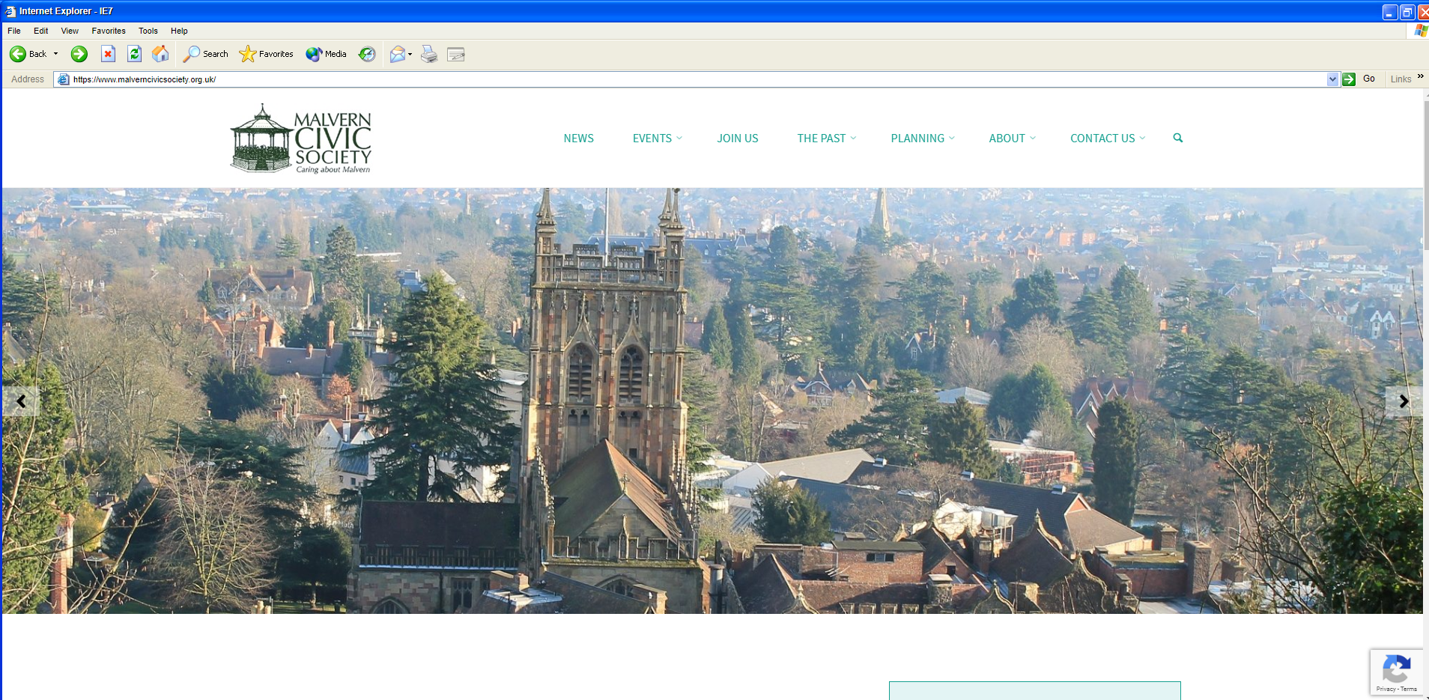

**Evaluation Part 1 - Design**

**I think the Koenigsegg website is better. The first reason is because of their rotating video/image background to show off what the organisation does; this shows that they care for providing details as opposed to just showing a picture of their airfield or a town. However, one problem with doing this is that it means they will need to add more files which means it could take slightly longer for the web page to load. Koenigsegg’s webpage has a very low contrast colour scheme as opposed to Malvern Civic Society’s webpage. From having these, they impact on the business in terms of providing attractive information using high quality pictures and bold facts and statements to a want to be customer.**

**However, the Malvern Civic Society’s website is also very simplistic, although it does have a very high contrasting colour scheme, using a light green on a white. The website is also very simple since it is designed for much less tech rich experienced users. It has simple drop-down menus and simple colours to make sure that it doesn’t become complicated and not useable.**

**So in conclusion, the best website for design, is the Koenigsegg website because of its simplicity as well as its beautiful pictures and videos provided with information that is enough to describe the organization.**

**Evaluation Part 2 - Performance**

**The performance of the Malvern Civic Society website is better than the Koenigsegg website. This is primarily because of that fact that the Koenigsegg website uses lots of videos and images as well as there being much more content in terms of words and diagrams.**

**However, whilst there is much more content on the Koenigsegg website, it still runs just as smooth as would be expected from a normal website, it is only the landing time which takes the longest because of the large file sizes.**

**In conclusion, the times of loading the website cannot be compared completely since it is based on performance, but when being based on loading time, the Malvern Civic Society wins. When basing the competition on general performance they are just as good as each other, although the Koenigsegg website has more assets and information on, it still performs just as well meaning that it is the better performing website.**